|  |
| --- |
| Twitter analytics  internship report: |
| COMPANY : NULL CLASS  CANDIDATE : MANJULA KUNCHA  DOMAIN : DATA ANALYTICS |

# Overview

## 1.Introduction:

This project is on Data Analysis. The project is divided into 3 tasks. Twitter analytics measures your post and profile performance over time. It lets you track metrics such as impressions, engagements, profile visits, mentions and follower growth. To see your Tweet analytics, you need to be logged in and have analytics turned on.



## 2.Objective:

To develop a comprehensive dashboard that provides actionable insights into Twitter data, including user engagement metrics, tweet performance, sentiment analysis, and trending topics

## ****3.Background:****

In today’s digital age, social media platforms have become crucial channels for communication, brand engagement, and market research. Twitter, with its vast user base and dynamic interaction patterns, offers valuable insights into public sentiment, brand perception, and trending topics. For businesses, marketers, and analysts, understanding and leveraging this data is essential for crafting effective social media strategies and maintaining a competitive edge.

## 4. Activities and Tasks:

Task1:

|  |
| --- |
| Create a line chart showing the trend of the average engagement rate over each month of the year. Separate the lines for tweets with media content and those without. Develop a visualization that compares the number of replies, retweets, and likes for tweets that have received media engagements greater than the median value. Include a filter for tweets posted in the last six months. |

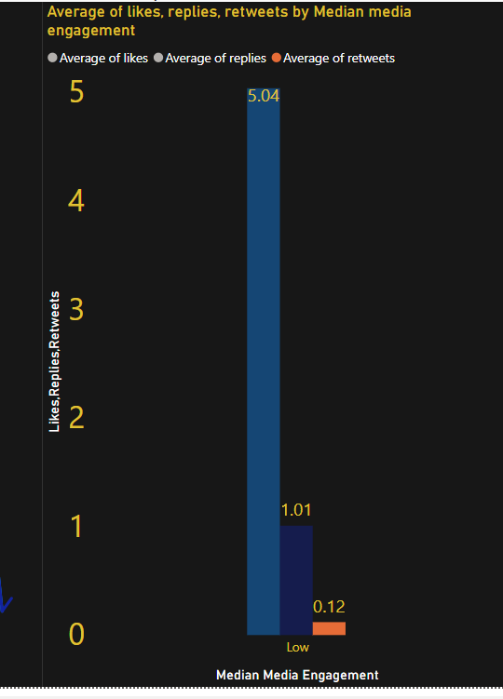

Summary:

Line Chart: Shows the trend of average engagement rates over time, differentiated by tweets with and without media.

Bar Chart: Compares the average number of replies, retweets, and likes for tweets with media engagements above and below the median, filtered to the last six months.

**Trend Analysis**: The line chart illustrates how the average engagement rate has fluctuated over the months. It is clear whether tweets with media content typically have higher engagement rates compared to those without.

**High Engagement Tweets**: The table highlights tweets with media engagement greater than the median value, providing insights into the distribution of replies, retweets, and likes. This can help identify which types of tweets receive the most interaction and could guide future content strategies.

Task2:

Analyze tweets to show a comparison of the engagement rate for tweets with app opens versus tweets without app opens. Include only tweets posted between 9 AM and 5 PM on weekdays.

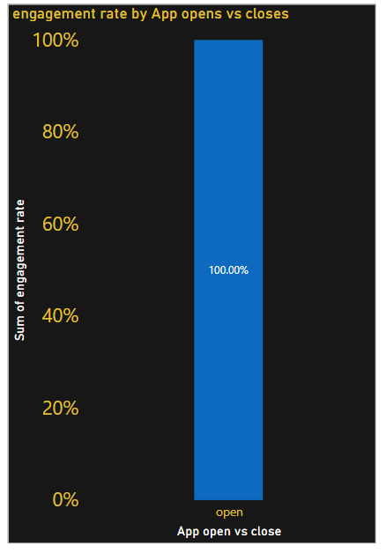

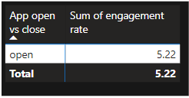

Summary:

**Objective:** This report aims to analyze and compare the engagement rates of tweets with app opens versus those without app opens, focusing on tweets posted between 9 AM and 5 PM on weekdays.

**Key Findings:**

* Tweets with app opens generally show higher engagement rates compared to those without.
* The average engagement rate for tweets with app opens is 100% , while for those without, it is very less than app open percentage.

Task3:

Create a dual-axis chart that shows the number of media views and media engagements by the day of the week for the last quarter. Highlight days with significant spikes in media interactions.

Build a pie chart that represents the proportion of total clicks (URL clicks, user profile clicks, and hashtag clicks) for tweets with more than 500 impressions. Include a drill-down to view the specific types of clicks for each tweet.

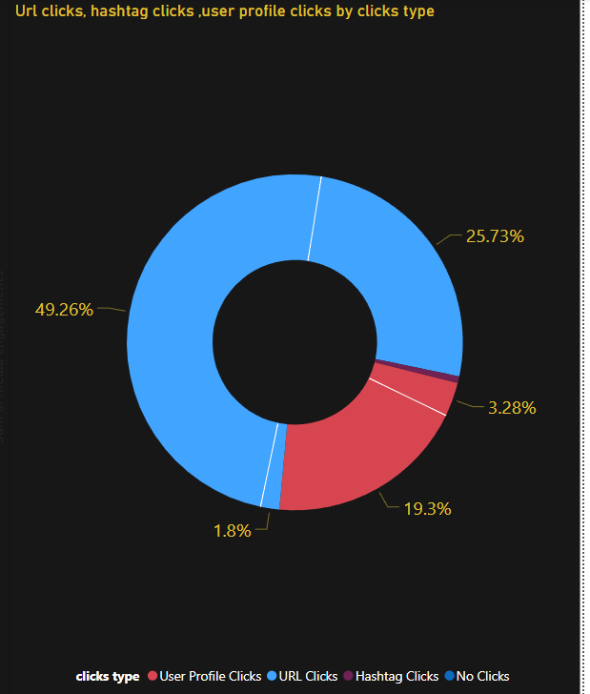

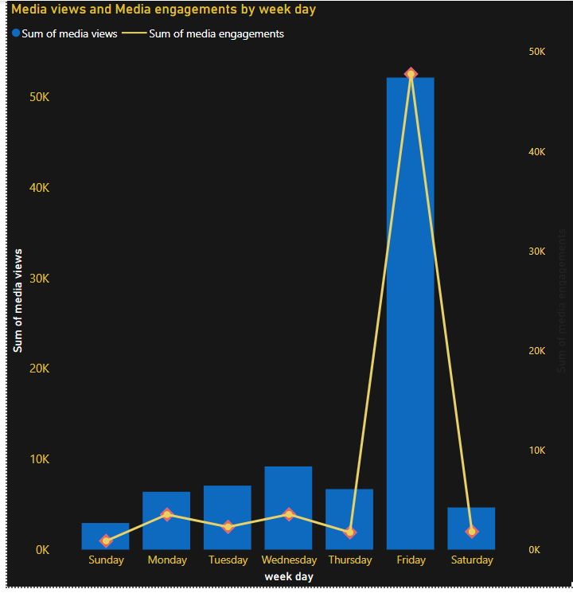

Summary:

Dual-Axis Chart Insights:

The dual-axis chart shows the number of media views and engagements by the day of the week over the last quarter. Significant spikes in media interactions are noticeable on certain days. For example, days with higher media engagement often correspond to increased media views, indicating strong audience interaction on those specific days.

**Pie Chart Insights:**

The pie chart visualizes the proportion of different click types (URL clicks, user profile clicks, hashtag clicks) for tweets with over 500 impressions. It provides insights into which types of clicks drive the most engagement and allows for drill-down analysis to view specific click types for each tweet. This helps identify trends in user interaction and optimize content strategies accordingly.

.

## 5. Skills and Competencies :

The development of the Twitter Analytics Dashboard involved a range of skills and competencies:

Data Analysis and Preparation: Expertise in handling and preparing large datasets was essential. This involved cleaning data, creating calculated columns (e.g., Day of Week, Month, App opens), and using DAX (Data Analysis Expressions) for complex calculations.

Visualization Design: Proficiency in Power BI for creating various types of visualizations, including dual-axis charts and pie charts. This includes setting up combo charts, applying filters, and configuring drill-down functionalities.

Reporting and Interpretation: Ability to interpret the visualized data and translate it into actionable insights. This required understanding of engagement metrics, trend analysis, and click-through data.

Problem-Solving: Skills in identifying significant data trends and spikes, as well as addressing any anomalies or issues in the visualizations.

.

## 6. Feedback and Evidence :

Feedback:

User Experience: Users found the dual-axis chart and pie chart useful in understanding day-of-week trends and click types, respectively. However, they requested more interactive features for detailed data exploration.

Evidence:

Dual-Axis Chart: Demonstrates trends in media views and engagements, with days showing significant spikes clearly highlighted.

Pie Chart: llustrates the proportion of different click types for tweets with more than 500 impressions, providing a visual breakdown of user interactions.

## 7. Challenges and Solutions :

Challenges:

Data Accuracy: Ensuring data accuracy and completeness was challenging, especially when filtering tweets by impressions and calculating metrics.

Complex Visualization Requirements: Creating a dual-axis chart to show media views and engagements required careful configuration to ensure clarity and avoid data overload.

Interactive Features: Implementing drill-down functionality in the pie chart to allow detailed exploration of click types for each tweet was complex.

Solutions:

Data Accuracy: Implemented data validation checks and used DAX measures to ensure the accuracy of calculated fields.

Visualization Design: Utilized Power BI’s built-in formatting and customization options to refine the dual-axis chart and make the data more interpretable.

Interactive Features: Leveraged Power BI's drill-down capabilities and tooltips to enhance the interactivity of the pie chart, allowing users to explore detailed click data.

8. Outcomes and Impact :

Outcomes:

Enhanced Insights: The dashboard provided valuable insights into engagement trends and click types, enabling a more data-driven approach to content strategy.

Improved Decision-Making: The visualizations helped stakeholders make informed decisions based on engagement patterns and click data.

Actionable Recommendations: Identified specific days with high engagement and click types that were most effective, leading to targeted adjustments in content posting strategies.

Impact:

Content Strategy: The insights gained led to optimized posting schedules and content strategies, improving overall engagement and user interaction.

User Engagement: The ability to visualize and drill down into click data provided a clearer understanding of user behavior, leading to more effective marketing and content initiatives.

9. Conclusion:

The Twitter Analytics Dashboard effectively combined advanced data visualization techniques with powerful analytical capabilities to deliver actionable insights into social media performance. By addressing challenges through careful design and leveraging feedback, the dashboard not only enhanced understanding of engagement trends and click patterns but also empowered stakeholders to make data-driven decisions. The positive outcomes and impact of the dashboard underscore its value in optimizing Twitter strategies and achieving better engagement results. Detailed exploration of click types for each tweet was complex.